*Electrotrade* |

| One Destination Making,

Right “Connections”

About Us

“A to Z Electrotrade” is India’s known channel partner of reputed Indian & International brands. The company flagged off in 2005 at Gurugram, Haryana situated in the Northern region of INDIA, the family business with a humble begining and king size dreams initiated the change in pattern of response and service to the customers.

Our business model is designed in an accuracy on providing services as committed to out customers. The committments of “A to Z” and their efforts have resulted in growth and expansion on the network. Today “A to Z” is a company spreading our hands in helping our customers to lower the supply chain cost with increase in efficiency and our efficient employees are working timelessly to fulfill the commitments we made..

A to Z Electrotrade Products

Pvc Wiring Channels

Electrical Cables

Electrical Wires



Switchgear

Din Rail

GROUP

Lighting

Cable Glands

Cable Lugs, Ties.

Wire Connectors

Circuit Protection

Much more....

“Trust takes years to Build’



Seconds to Break’

And Forever to Repair”

Why A to Z ?

Our Expertise in Logistics, Quality, Wareshousing and endless customer support have lead us achieve today this reputation on being India’s known channel partner of electrical goods. Today A to Z Electrotradeis an independent, Family owned group focused on B-to-B distribution. We thrive on our unique balance on local empowerment.

Our job is to make our customers lives easier, so we dedicate ourselves to understanding and satisfying their needs, while our core business is in the electrical market, we serve customers through multiple channels of dustribution, with an expanding range of products, services and solutions.

Through our distribution channels we provide high standards quality assurance goods with required certifications, inspections and regulators services to manufacturers, brand owners, dustributors, buying associations, consumer associations and retailers.

**_____________________________________________________________________________________**

Contact us

A to Z Electrotrade (India) Pvt. Ltd.

Plot no. 14, Basai Industrial Area, Basai

Gurugram-122006, INDIA

Phone: +91- 9910094184, 9910094164

Email: [frontdesk@atozco.in](mailto:frontdesk@atozco.in)

Website: [www.atozco.in](http://www.atozco.in)

*Electrotrade* |

| One Destination Making,

Right “Connections”



**PASSION**

• Commitment in everyday work:

the strength of our engagement

• Keep on learning and sharing our know-how

• Enthusiasm about our products and services

• Desire to contribute to making things better

and innovate

**RESPECT**

* • Basics of all our relationships and guarantee for our position in the long term
* • An attitude: listen and learn
* • A behavior: show respect to win respect
* • Create trustful relationships to reinforce our added value

**CUSTOMERS**

• Focus of our attention: listen to them, identify their needs, organize ourselves to satisfy them better

• Be the technical support for our customers

• Our customer-service quality: an added value to our suppliers

• Provide a service of proximity



**SYNERGIES**

* • Promote contracts, organize processes
* • Share ideas, know-how, experiences: learn from each other to increase our efficiency
* • Look for solutions together
* • Make profit of the many local cultures

“We forgive a lot,

But we never forget what is Said and Done”

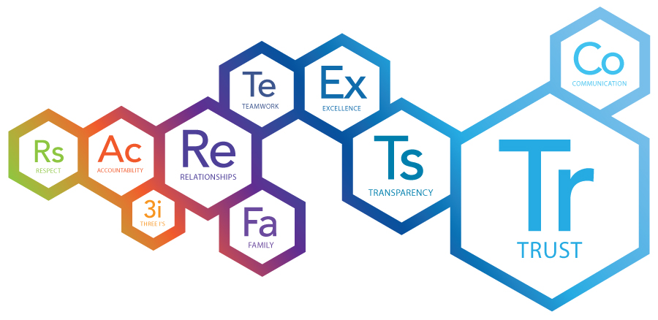

Committments

We believe that we will demonstrate by focussing on company objectives and the needs of our customers

Respect

We believe we respect people for their well being as well as recognize each other efforts and contribution

Managed Experienced Team

A young and dynamic work environment filled with innovation and ideas which lead or leading to strong relationships and mutual respect

*Electrotrade* |

| One Destination Making,

Right “Connections”

**Message from Director’s Desk**

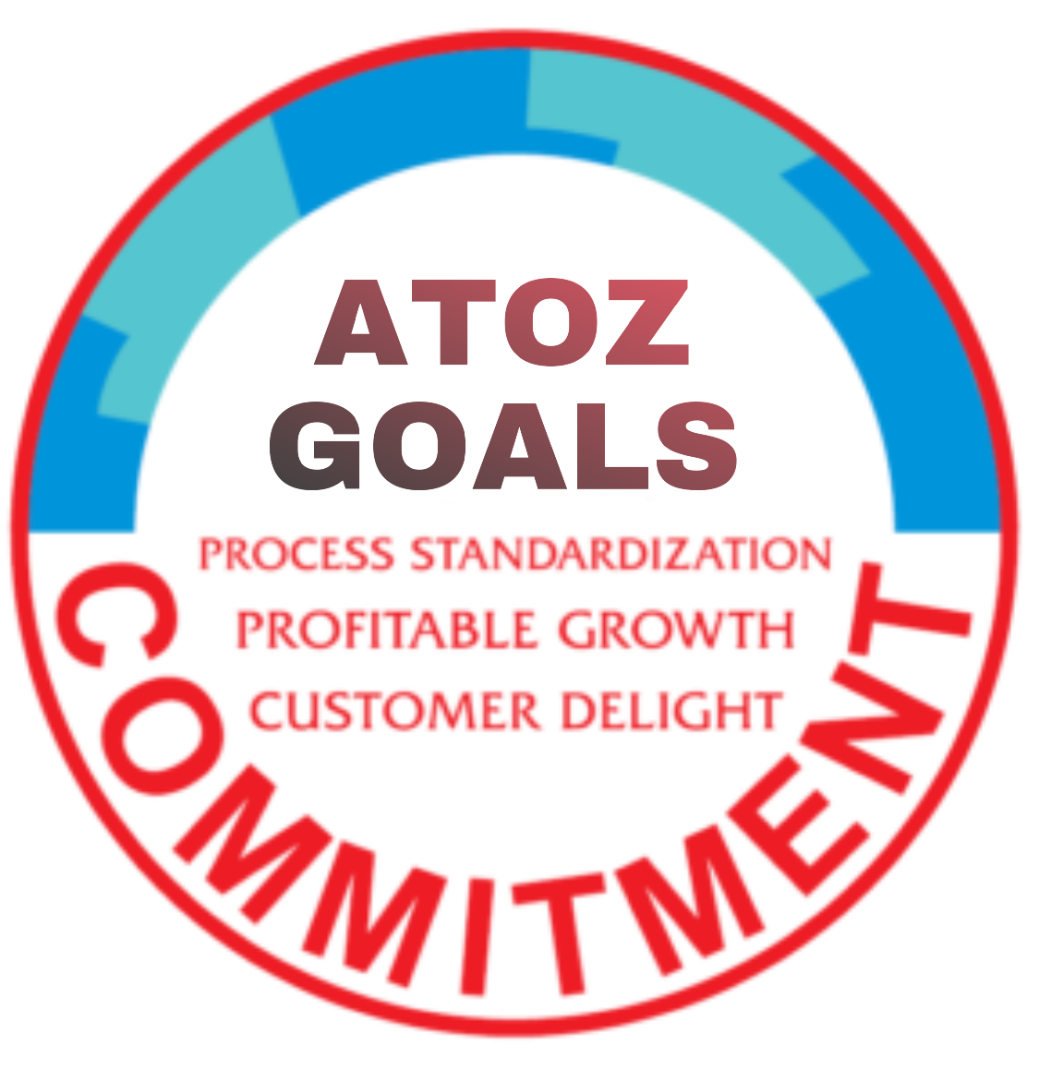

 I would like to introduce our Company Goals

Whenever we have Goals, we need to make them measurable, and for this measure we introduce our Key Perfomance Indicators or KPI’s – these KPI’s should pertain your responsibilities within the organization and hence those aread where the results will directly impact the above goals – those should be the KRA’s.

For Example , for a sales person, the first goal translates the KRA’s to his/her target , the second to the Gross Margin of their orders, the third to Sales operation processes which they are supposed to follow and the last, professional and personal development including his/her required trainings, skill development etc.

Another example would be a person from Operations – the first goal translates the KRA’s to her revenue target, the second to productivity therefore profitability, the third is following of the various processes for revenue generation and the last to the training & development in both his/her professional and personal domain.

I would also draw your attention to one of the precepts which our Great Indian Army follows-

**Proper Planning leads to Prolific Performance.**

Please think about strategy and plan your work- there has to be a master plan for the year, a backup plan for contingencies, a plan for the quarter , a plan for the month and of course a weekly plan.

If some thought is given to our plans, then we can devise strategy which would make us more productive, more efficient and more adaptable.

Let us strive this year to overachieve our targets and Goals  

________________________________________________________________



**-*Rajiv Gulati***

***-Director – A TO Z Group***

________________________________________________________________

Contact us

A to Z Electrotrade (India) Pvt. Ltd.

Plot no. 14, Basai Industrial Area, Basai

Gurugram-122006, INDIA

Phone: +91- 9910094184, 9910094164

Email: [frontdesk@atozco.in](mailto:frontdesk@atozco.in)

Website: [www.atozco.in](http://www.atozco.in)

*Electrotrade* |

| One Destination Making,

Right “Connections”

Corporate Governance at A to Z Group

#### Who we are is defined by what we do and how we do it.

This simple philosophy underlines our approach to Corporate Governance. So, if profit is our intention, how we achieve this profit is a part of our Corporate Governance. For us, Corporate Governance goes beyond philanthropy and compliance but actually deals with how we manage our triple bottom lines – economic, social and environmental impacts. It monitors our role as well as the quality of our relationships in key spheres of influence including the workplace, the market place, the supply chain, the community and the public policy realm.

As a Company, we distinguish ourselves in the market by offering a portfolio of ecologically responsible electrical products and services that deliver powerful, sustainable, and energy efficient solutions that do not compromise on capacity or security.

Our eco-friendly approach is evident in our efforts to develop an alternate energy strategy so as to reduce the environmental impact of our business. We are equally committed to managing a responsible supply chain in a manner that is consistent and compliant with our high standards for environment and business practices.

We recognize that there are barriers that 'constrain innovation, both, in individuals and communities, and we work to overcome them.' We build communities and promote the exchange of ideas through assistive technologies; participative programs and standardization that transforms the way people experience our products. Our energy efficient solutions enable people to save money and protect their capital investment while also lowering their energy usage and protecting the environment.

## Corporate Governance and Ethics

As a Company we have always worked on the side of ethics and have shunned expediency in any form. We believe that if something is important enough to be done, it is important that we do it ethically. We supplement our traditionally held values of ethical behavior and moral conduct with explicit rules and regulations that guide our efforts in financial, propriety, customer care and business excellence.

We uphold the policy of "Leadership with trust" that has come to play a vital role in how our customers perceive us. This is important, given the climate of unparalleled public distrust of people in positions of power and authority in contemporary business and politics.

What we believe

We drive our long-term, profitable and sustainable growth by:

• Striving for lasting loyalty from our Customers

• Securing the engagement of our skilled and passionate

Associates

• Building strong partnerships with our preferred

Suppliers

• Aligning ourselves with the vision and commitment of

our Shareholders

________________________________________________________________

Contact us

A to Z Electrotrade (India) Pvt. Ltd.

Plot no. 14, Basai Industrial Area, Basai

Gurugram-122006, INDIA

Phone: +91- 9910094184, 9910094164

Email: [frontdesk@atozco.in](mailto:frontdesk@atozco.in)

Website: [www.atozco.in](http://www.atozco.in)

*Electrotrade* |

| One Destination Making,

Right “Connections”

Market

At A to Z, we strive to provide our customers with services and products that not only meet their expectations but exceed them. We continuously improve in what we do and our job is to make customer’s lives easier by –

***- DELIVERING***



-The right product, at the right place, time & price

***- ADVISING***



- On products, solutions & innovation

***- SUPPORTING***



-To provide training, tools, services via branches, telephone etc

Vision if the Art of seeing,

What is invisible to others.

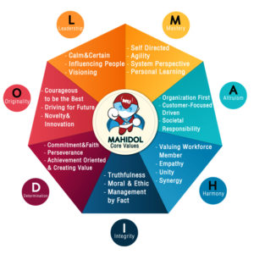 OUR VISION

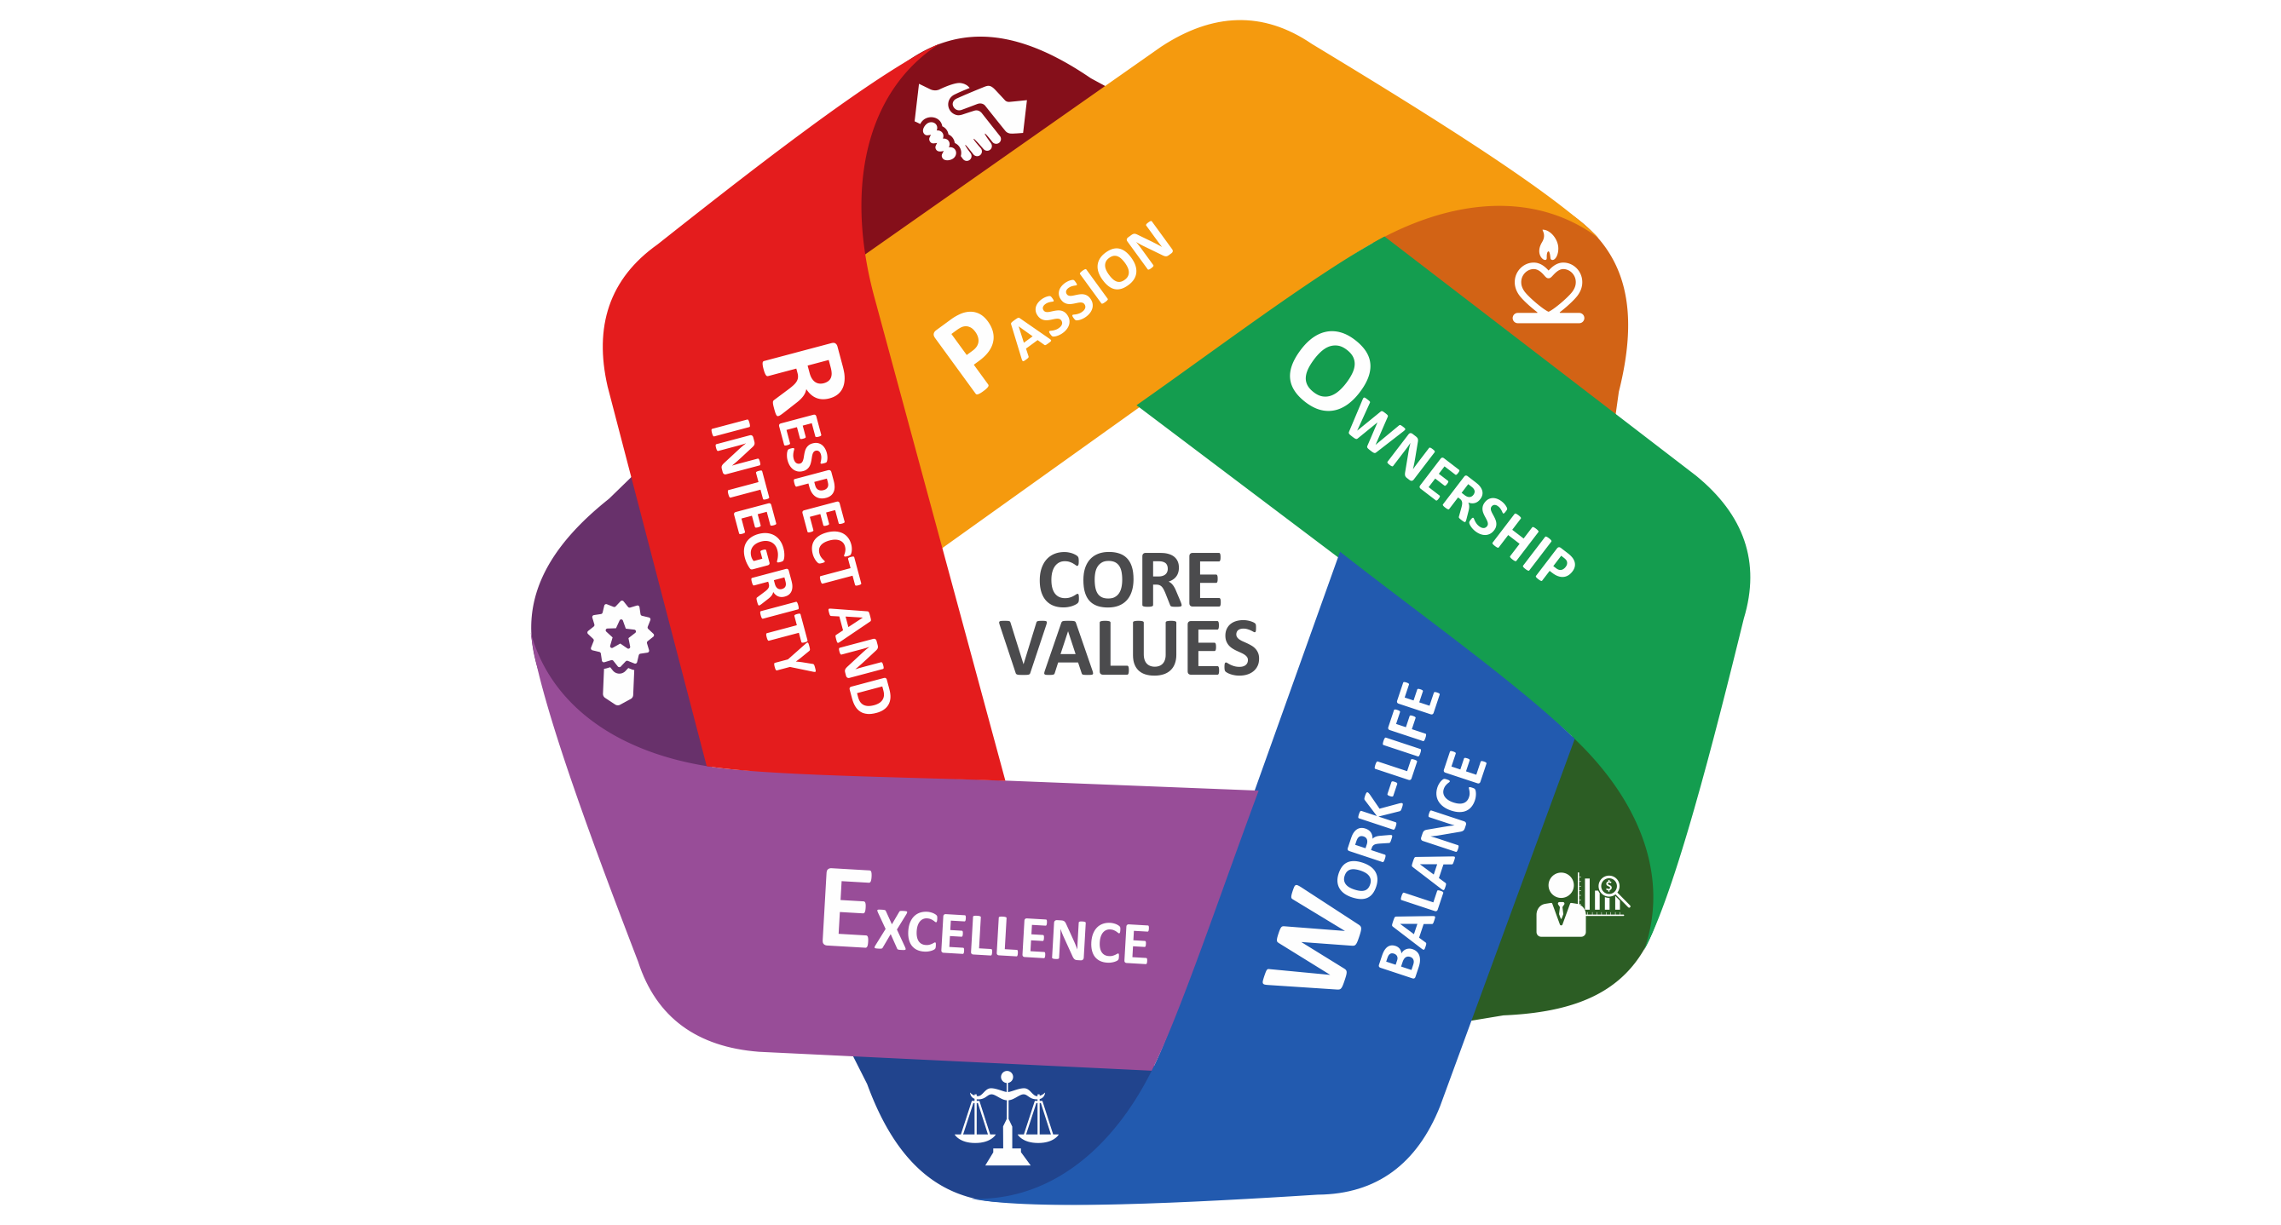CORE PURPOSE

“To Provide world class solution to our believers through innovative system and process. We aspire to delight our believers by preforming better than their expectations”

BRAND PROMISE

“100% Customer Delight by offering Electrical Products and Services ahead of time.”

CORE VALUES

Integrity, Ethical and Transparent Working

We treat everyone as we like to be treated. Respect Diversity

Passionale and Innovative

Everyone Passion to excel and innovative in finding solution

Accountability

Excel Responsible for Action. Focus on speed: Mental: Physical and Emotional. So you sow, so you reap.

Communication

Excel Encourage open communication to shareopinions and views.

Team Work

Responsible Team work is a ability to work as a group toward a common vision even if that vision becomes extremely blurry.

________________________________________________________________

Contact us

A to Z Electrotrade (India) Pvt. Ltd.

Plot no. 14, Basai Industrial Area, Basai

Gurugram-122006, INDIA

Phone: +91- 9910094184, 9910094164

Email: [frontdesk@atozco.in](mailto:frontdesk@atozco.in)

Website: www.atozco.in